2520030048, Teja Hasini Reddy
=========================================================
SECTION 1 : DDL (DATA DEFINITION LANGUAGE)
=========================================================
DDL COMMANDS:
1. CREATE
2. ALTER
3. DROP
4. TRUNCATE
5. RENAME
=========================================================
QUESTION 1 - CREATE TABLE
=========================================================
SCENARIO:
The bank wants to create a table to store
customer transaction details.
QUERY:
CREATE TABLE bank_transactions (
txn_id INT PRIMARY KEY,
customer_name VARCHAR(50),
branch_name VARCHAR(50),
transaction_type VARCHAR(20),
amount DECIMAL(10,2),
transaction_date DATE
);
Output:

=========================================================
QUESTION 2 - ALTER TABLE ADD COLUMN
=========================================================
SCENARIO:
The bank wants to store account numbers for every transaction.
QUERY:
ALTER TABLE bank_transactions
ADD account_no VARCHAR(20);
Output:
=========================================================
QUESTION 3 - ALTER TABLE MODIFY COLUMN
=========================================================
SCENARIO:
The bank wants to increase customer name length.
QUERY:
ALTER TABLE bank_transactions
MODIFY customer_name VARCHAR(100);
Output-
=========================================================
QUESTION 4 - RENAME TABLE
=========================================================
SCENARIO:
The bank wants to rename the transaction table.
QUERY:

RENAME TABLE bank_transactions
TO customer_transactions;
Output-
=========================================================
QUESTION 5 - TRUNCATE TABLE
=========================================================
SCENARIO:
The testing team wants to remove all records without deleting the table structure.
QUERY:
TRUNCATE TABLE customer_transactions;
Output-
=========================================================
QUESTION 6 - DROP TABLE
=========================================================
SCENARIO:
The bank no longer requires an old backup table.
QUERY:
DROP TABLE customer_transactions;
Output-
=========================================================
SECTION 2 : DML (DATA MANIPULATION LANGUAGE)
=========================================================
DML COMMANDS:
1. INSERT
2. UPDATE
3. DELETE
4. SELECT
=========================================================
STEP 1 : INSERT SAMPLE DATA
=========================================================
QUERY:
INSERT INTO bank_transactions VALUES
(101,'Ravi','Hyderabad','Deposit',5000,'2024-01-05'),
(102,'Sita','Hyderabad','Withdrawal',2000,'2024-01-06'),
(103,'Kiran','Vijayawada','Deposit',12000,'2024-01-08'),
(104,'Anil','Vizag','Deposit',8000,'2024-01-10'),
(105,'Priya','Hyderabad','Withdrawal',3500,'2024-01-11'),
(106,'Ramesh','Vizag','Deposit',15000,'2024-01-12'),
(107,'Keerthi','Vijayawada','Withdrawal',1000,'2024-01-13'),
(108,'Rahul','Hyderabad','Deposit',9000,'2024-01-14'),
(109,'Sneha','Vizag','Withdrawal',4000,'2024-01-15'),
(110,'Madhu','Vijayawada','Deposit',11000,'2024-01-16');
Output-
=========================================================
QUESTION 7 - INSERT
=========================================================
SCENARIO:
A new customer transaction must be recorded.
QUERY:
INSERT INTO bannk_transactions
VALUES
(111,'Venu','Vizag','Deposit',7000,'2024-01-18');

Output-
=========================================================
QUESTION 8 - UPDATE
=========================================================
SCENARIO:
Customer Priya's transaction amount was entered incorrectly and must be corrected.
QUERY:
UPDATE bannk_transactions
SET amount = 5000
WHERE txn_id = 105;
Output-
=========================================================
QUESTION 9 - DELETE
=========================================================
SCENARIO:
A duplicate transaction record must be removed.
QUERY:
DELETE FROM bannk_transactions
WHERE txn_id = 111;
Output-
=========================================================
QUESTION 10 - SELECT
=========================================================

SCENARIO:
The branch manager wants to view all transactions.
QUERY:
SELECT *
FROM bannk_transactions;
Output-
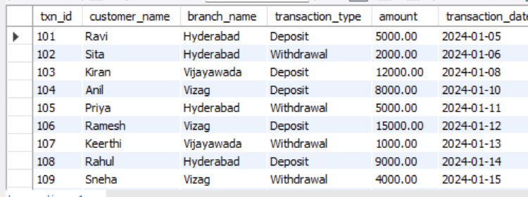
=========================================================
QUESTION 11 - SELECT WITH WHERE
=========================================================
SCENARIO:
The manager wants all deposits only.
QUERY:
SELECT *
FROM bannk_transactions
WHERE transaction_type='Deposit';
OUTPUT:
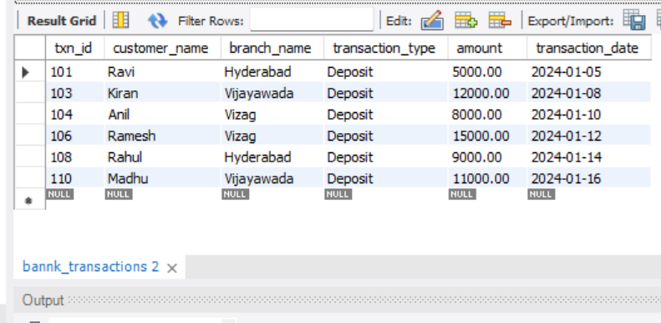
=========================================================
QUESTION 12 - SELECT WITH ORDER BY
=========================================================
SCENARIO:
Management wants transactions ranked by amount.
QUERY:
SELECT *
FROM bannk_transactions
ORDER BY amount DESC;
Output-
=========================================================
SECTION 3 : DCL (DATA CONTROL LANGUAGE)
=========================================================
DCL COMMANDS:
1. GRANT
2. REVOKE

=========================================================
QUESTION 13 - GRANT SELECT
=========================================================
SCENARIO:
The bank wants to allow Auditor1 to view transaction data.
QUERY:
GRANT SELECT
ON bannk_transactions
TO Auditor1;
Output-

=========================================================
QUESTION 14 - GRANT ALL PRIVILEGES
=========================================================

SCENARIO:
The DBA wants to provide complete access
to BranchManager.

QUERY:

GRANT ALL
ON bank_transactions
TO BranchManager;

OUTPUT:

Privileges granted.

=========================================================
QUESTION 15 - REVOKE SELECT
=========================================================

SCENARIO:
Auditor1 no longer requires access.

QUERY:

REVOKE SELECT
ON bank_transactions
FROM Auditor1;

OUTPUT:

Privilege revoked.

=========================================================
QUESTION 16 - REVOKE ALL
=========================================================

SCENARIO:
Temporary access granted to a user
must now be removed.

QUERY:

REVOKE ALL
ON bank_transactions
FROM BranchManager;

OUTPUT:

Privileges revoked.

=========================================================
SECTION 4 : TCL (TRANSACTION CONTROL LANGUAGE)
=========================================================

TCL COMMANDS:
1. COMMIT
2. SAVEPOINT
3. ROLLBACK

=========================================================
QUESTION 17 - COMMIT
=========================================================

SCENARIO:
After updating multiple transactions,
the manager wants to permanently save changes.

QUERY:

UPDATE bank_transactions
SET amount=6000
WHERE txn_id=101;

COMMIT;

OUTPUT:

Transaction committed successfully.

=========================================================
QUESTION 18 - SAVEPOINT
=========================================================

SCENARIO:
The bank wants a recovery point before
making bulk updates.

QUERY:

SAVEPOINT Before_Update;

OUTPUT:

Savepoint created.

=========================================================
QUESTION 19 - ROLLBACK TO SAVEPOINT
=========================================================

SCENARIO:
An incorrect update was performed and
must be reversed.

QUERY:

UPDATE bank_transactions
SET amount=99999
WHERE txn_id=102;

ROLLBACK TO Before_Update;

OUTPUT:

Changes rolled back to savepoint.

=========================================================
QUESTION 20 - FULL TCL EXAMPLE
=========================================================

SCENARIO:
The bank processes multiple updates and
wants the option to undo some of them.

QUERY:

UPDATE bank_transactions
SET amount=7000
WHERE txn_id=101;

SAVEPOINT SP1;

UPDATE bank_transactions
SET amount=9000
WHERE txn_id=102;

ROLLBACK TO SP1;

COMMIT;

OUTPUT:

Transaction 101 updated and saved.
Transaction 102 restored to previous value.

=========================================================
SUMMARY OF COMMANDS
=========================================================

DDL COMMANDS
------------
CREATE
ALTER
DROP
TRUNCATE
RENAME

DML COMMANDS
------------
INSERT
UPDATE
DELETE
SELECT

DCL COMMANDS
------------
GRANT
REVOKE

TCL COMMANDS
------------
COMMIT
SAVEPOINT
ROLLBACK

=========================================================
INTERVIEW TIPS
=========================================================

TRUNCATE
---------
Deletes all rows.
Cannot use WHERE clause.
Faster than DELETE.
Resets storage.

DELETE
-------
Deletes selected rows.
Can use WHERE clause.
Can rollback before commit.

DROP
-----
Deletes table structure and data completely.

COMMIT
-------
Makes changes permanent.

ROLLBACK
---------
Undo changes before COMMIT.

SAVEPOINT
----------
Creates a checkpoint inside a transaction.

GRANT
-------
Gives permissions.

REVOKE
--------
Removes permissions.

=========================================================
END OF DDL, DML, DCL, TCL NOTES
=========================================================

